IHE Work Item Proposal (Short)

# Proposed Work Item: Point-of-care Medical Device Manager to improve patient safety, documentation clarity, and decision support

Proposal Editor: Ioana Singureanu ([Ioana.singureanu@bookzurman.com](mailto:Ioana.singureanu@bookzurman.com)) on behalf of the Department of Veterans Affairs

Work item Editor: Ioana Singureanu

Date: September 27, 2016

Version: 1.0

Domain: Patient Care Coordination

# The Problem

* Medical device measurements, settings, status, and alarms are transmitted to patient care system (e.g. ICU flowsheet) using existing standard transaction (e.g. IHE PCD-01 transactions based on HL7 Version 2. 7 ORU_R01) include only the device identification without patient identification information. This means that the receiving system (implementing Device Observation Consumer – DOC actor) is unable to match the device data with the correct patient. This leads to missing or erroneous data and could further lead to patient safety issues
* Implantable life-sustaining or life-supporting devices must be tracked to the patient and recorded along with procedure in the EHR to meet Meaningful Use 2015 certifications criteria. This information is necessary to address adverse events and recall notices specify to a device instance (based on device unique device identified using the FDA-specified UDI in the US). Currently we do not have a standard-based mechanism to capture the information consistently across care setting (e.g. hospital Operating Room, cardiology clinic, orthopedic surgery clinic).
* Medical device data may be persisted to the patient’s chart (if “validated/accepted” by clinicians), used for decision support, and exchange with other providers across the continuum of care (e.g. as referrals, transfer, discharge summary documents based on HL7 Consolidated CDA).

# Key Use Case

The main use case is to provide a standard-based approach to accomplish Patient-Device and Device-Operator Associations and Management using FHIR Procedure, FHIR Device, and UDI

The main scenario uses FHIR Procedure and Device to associate a patient to one or more device(s) and operator/nurse/physician who configured or implanted the device. The device will be identified using the UDI scanned at the point of care along the patient id wristband, and the provider's badge.

* Create a FHIR Procedure specifying the patient, the device or devices involved, and the operator (i.e. nurse, respiratory therapist, etc.) or provider who configured the device, validated its configuration and initiated the procedure.
* If the device is implanted, a FHIR Device resource will associate the patient with the implanted device. The Patient Device List will be created by querying the EHR using a Device.search (by patient) operation.
* If the device is used monitor the patient or administer medication the procedure indicates duration, the associated medication order.

The scenario involves a new actor: **Point-of-care Device Manager**

This is a new actor is an HL7 FHIR client intended to track implantable devices, associate a patient to their monitoring devices, or help validate medication administration at the point of care using an infusion pump. The actor Manager implements several FHIR resources (as a client) in order to:

* start and end a monitoring session as a [Procedure](http://hl7-fhir.github.io/procedure.html) "in-progress" and updates the procedure at the end of the monitoring session (and set the status to "complete")
* create a [Device](http://hl7-fhir.github.io/device.html) resource corresponding to each device implanted during a surgical procedure and creates [Procedure](http://hl7-fhir.github.io/procedure.html) to document it.

**NOTE:** These interactions represent new capabilities to allow a Device Manager

to assign devices (implanted or used for treatment) to a specific patient.

Currently integrator use an ad-hoc HL7 V2 visit or appointment notification to start and stop a device monitoring session.

The following user stories illustrate the use case for three types devices using a common set of resources/transactions:

## Tracking Implantable Devices

* SSgt. Sam Share, a **veteran**, receives a **consult** from Dr. Lister at a VA facility to treat his combat-related **condition**. It requires an implantable device to improve Sam’s health status.
* Dr. Lister, **VA physician**, prescribes an **implantable device or tissue** based on device type and other criteria (e.g. clinical size) and **orders** the **device** (based on device identifier (DI portion of UDI) the **procedure** (HCPCS)
  + The VA physician Looks up a suitable device using **prosthetic** list based on the FDA Global Unique Device Identifier Database (GUDID) or uses the pre-loaded “gold” Master Device Identifier file
    - By type, model, version, vendor, clinical size
* Ms. Martin, a **VA clerk** reviews the order before forwarding the information from the VA-approved distributor and obtains the device required for SSgt. Sam.
* A **procedure** is **scheduled** for SSgt. Sam, the device is implanted by Dr. Wilson and the UDI is scanned by the designated nurse into VistA. The UDI is associated with the patient and available to community providers in the “Patient Device List” of a CCD. If a recall is initiated, the manufacturer notifies VA to inform Sam and other patients using the same type of device in the affected production.

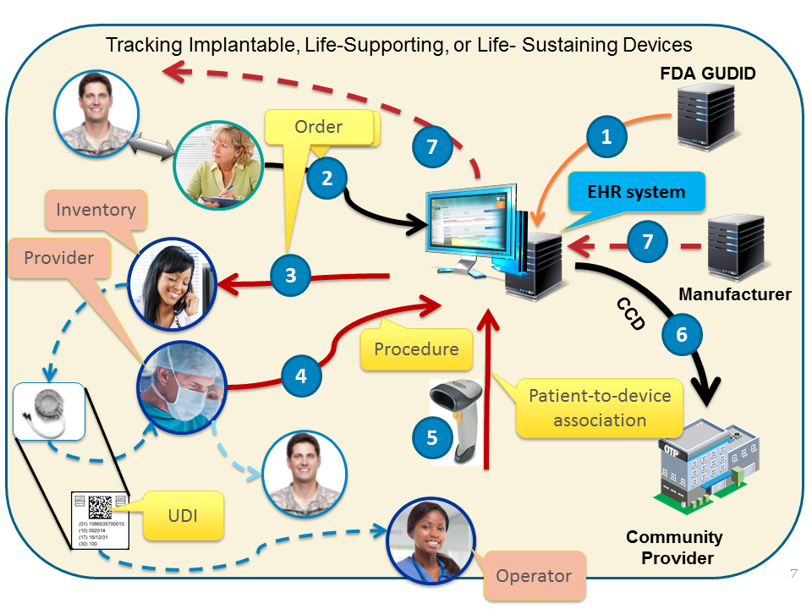

## Vital Signs Monitoring and Charting

* SSgt. Sam Share (ret.) is admitted at the VA medical center and requires **continuous monitoring** of vital signs including oximetry. Dr. Lister orders monitoring for the next **24 hours**.
* Nurse Nightingale starts the monitoring session by **assigning** a standard-based vital sign monitor to Sam by **scanning the device label** and Sam’s **wrist band** (UDI🡨🡪PID) and her badge (PID🡨🡪EID). She uses the vendor-provided medical device manager or a VA-provided device gateway to record the devices associated with this procedure and patient.
* Once the patient-to-device association is completed any measurements, status information, reference ranges, etc. acquired by the device is exchanged with the flowchart system that persists the measurement in the VistA database using a common device integration adapter. **LOINC, SNOMED, UCUM** used to convey the measurements.
* Throughout the monitoring session, Ms. Nightingale validates the data entered by the integrated device into VistA. The validated results become part of Sam’s legal health record
* The CCD includes relevant/pertinent vital signs along with other treatment information

### 

## Smart Device Programming and Tracking

* SSgt. Sam Share (ret.) is admitted at the VA medical center and requires medication administered intravenously using a “smart” pump. If used properly, “smart” pump features help prevents I.V. medication errors and reduce patient harm. Dr. Lister orders the drug, dose, route, time/frequency.
* The **patient**, **medication**, **dose**, **route**, **time/frequency** is sent to the infusion pump gateway.
* Nurse Nightingale starts the IV drug administration by assigning a “smart” pump to Sam by scanning the device UDI and Sam’s wrist band and her badge (**UDI**🡨🡪**PID 🡨🡪EID**) she establishes the patient, device, and operator of the device (EHR may verify it…)
* Once the patient-to-device association is completed, the pump gateway is able to associate the ordered medication with the pump assigned to Sam.
* Once the Ms. Nightingale validates the “5 rights” the device will send events and other administration information to the patient’s record. The medical device integration adapter used by the enterprise persists the information in the VistA database
* Throughout the IV session, Ms. Nightingale validates the data entered by the integrated device into VistA. The validated results become part of Sam’s legal health record. The EHR/VistA application to record documentation and validate reason and response to the medication

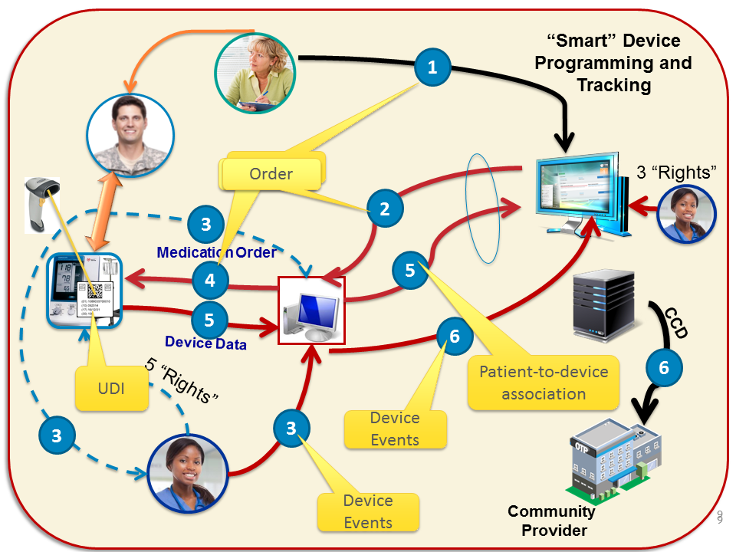

# Standards & Systems

The Point-of-care Device Manager may implement both PCD-01 and FHIR-based transactions:

* Patient search
* Device create
* Procedure create, update
* ProcedureRequest create, search

# Discussion

An IHE Profile and Transaction specification would specify a well-defined sequence/workflow that reference FHIR profiles developed by IHE and HL7 project to promote reuse.